Filming & Editing Your Ads
Filming & Editing Your Ads

Introduction

We're going to break down the entire process of filming, recording, and editing your video ads from recording on your iPhone in your bedroom to hiring and managing a team of creators and editors.

Do It Yourself or Delegate?

When it comes to recording ads, you have two options:
- You can record them yourself
- You can hire a UGC (User-Generated Content) creator to do it for you.

The default path, especially in the beginning, is that you should record them yourself. This is one of the highest-leverage skills you can learn. If you can sell on a sales call and you can sell on a video ad, you will never be poor.

The only time you should delegate this immediately is if you have a variable that is going to actively break trust with your market.

For ex: if you're from Slovakia with a really thick accent trying to target US-based doctors, it's going to be an uphill battle. In that case, it makes sense to delegate from day one.

Now obviously there’s a fine line here between you having a competitive disadvantage and just not having experience - Feeling camera shy or not being "charismatic" enough isn’t a valid excuse not to record video ads.

For context; when I first started my videos were shit (as like any other skill you wanna develop…) This is a skill you learn through repetition, not a personality trait you're born with. The pain of learning this skill is far less than the pain of your business staying stagnant because you were afraid to get on camera.

When & Why to Delegate

As you scale, hiring UGC creators becomes a massive point of leverage. It buys back your time so you can focus on high-revenue activities instead of spending a day every two weeks recording ads.

More importantly, a good UGC creator can often get you better results because of market congruency. People buy from people who look and sound like them. If I’m 19 with bad skin, running ads to med spa owners in their mid 30-50’s, my face on an ad doesn’t exactly scream "expert."

This is why when we hire a UGC creator, we look for someone who fits into one of two buckets:

- Someone who looks like they’re in their retirement years
  - They look, act, and talk like the people you're trying to sell to
- Someone your ICP would be attracted to friendly neighbor or local.
  - If you're in Texas, it could be a good idea to use someone who dresses like a local in Texas

Example:
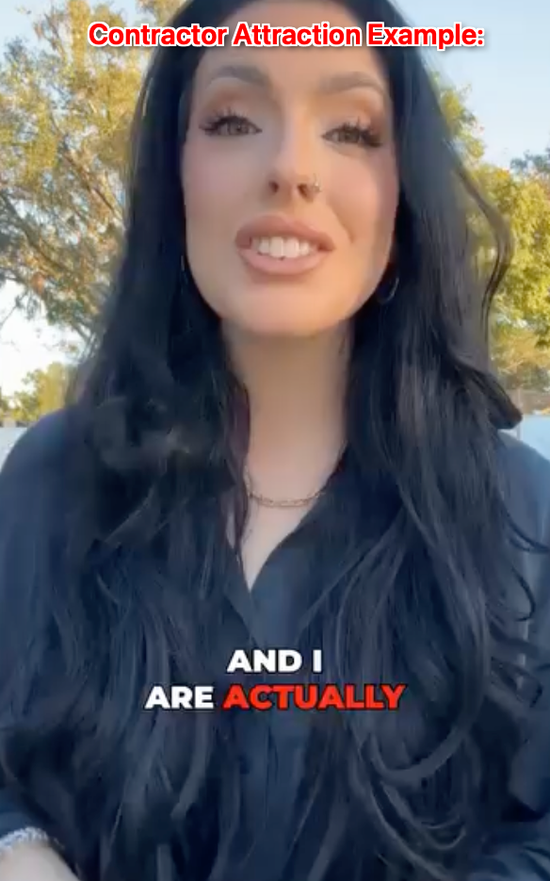

The final reason to use UGCs is to combat creative fatigue. I spent over $200,000 on ads with one specific UGC creator and after a year, people were seeing the same face every single day. Our results started to dip, not because the ads were bad, but because the market was tired of seeing the same face on their feed 24/7.

The leading indicators were a slow decline in CTR and a steady climb in our Cost Per Booking. We had to start cycling in new faces to keep things fresh (this is incredibly true if you are running ads in a small market with a TAM of 20k>...)

Keep in mind that If your agency or your business is purely dependent on your brand and your face to grow (you have a big organic presence and a lot of people know you), this wouldn’t make sense for you to do at a small scale.
- However, for most agencies that's not the case

So the key point being you should be the one recording your video ads to start, however if you have a competitive disadvantage, OR you have some cash to burn on testing 2 faces right out the gate (you and a UGC creator) then absolutely do it.

Recording Your Ads

Pre-Recording Checklist
- Energy is EVERYTHING
  - If your energy is low and your tonality is off, your ads will not perform
  - Example Comparison
- Congruence is King
  - Your environment, your clothing, and your overall vibe need to be congruent with the audience you're targeting.
  - Batch Your Recordings.
  - When you record, do all the hooks in one continuous clip, and then all the bodies in another. Don't stop and start. If you screw up a line, just pause for a second and say it again and get editors to fix it. This saves a massive amount of time stopping and starting the recording each time.

There’s 2 different recording setups I’ll be breaking down below - One is for if you have no equipment, the other one is for if you do.

1: The Basic Iphone Setup

If you have no equipment, all you need is an iPhone 11 or newer (the cameras on older ones are shit).

- Get a cheap tripod (Example)
- Download the Captions app and put your script into the teleprompter section
- Prop up your phone, and hit record. That's literally it.
  - You can even use the app to do basic edits if you don't have the cash to hire an editor yet or just want to launch ads with speed

VIDEO SOP

2: The Advanced Camera Setup

If you want to level up your quality, which is more about brand perception (people associate quality with cost…) here’s the equipment I’d recommend investing in: Recommended Equipment For Ads List

The process for recording is pretty much exactly the same, only difference is we do it on our computer instead:

- Put your script in a Google Doc at the top of your screen
- Record using a high-quality platform like Screenflow
- Export in 1080x1920 (vertical) or 1080x1080 (square)
  - I’d recommend testing both

VIDEO SOP

Hiring UGC Creators

When it comes to hiring a UGC creator, the key is hiring people who fit into the 2 buckets we discussed earlier - lookalike OR attraction.

- Find the UGC Creator
  - Be prepared to play the volume game. We've hired over 20 UGC creators, and only 3-4 of them performed really well on our ads. Even the people you think will crush on ads might not, it’s all a game of testing with the highest probability of success
  - Platforms to source find them:
    - Backstage
    - Insense
    - Billo
    - Referrals - best place is people you already know - put it in the license and scale slack to get help with this
      - Avoid FIVERR at all costs (most are overcharging)
  - Red Flags: Before you even offer a test, look for red flags in their example videos
    - Do they have low energy? Do they sound like a cheesy 1980s TV commercial? Do they look nothing like your ICP or the person your ICP would be attracted to? If yes, move on.
- Validate they have what it takes
  - Always start with a paid test project. We use a templated outreach message to haggle down their price and set clear expectations for a small batch of hooks and one body
  - If they pass the test, we onboard them into Slack, agree on a price per batch, and get to work.
  - This is all a volume game, get a VA on your team (or yourself) to do X amount of outreach per day, here’s what you’ll send them: UGC Hiring Outreach Script
  - From there agree on payment terms per project and you’re all set
  - Once they accept, here’s a template on delivering instructions to the project: UGC-Style Video Ad Script
- Get them under contract at scale
  - If you find a creator who is an absolute outlier and is crushing it for you, get them under contract. This prevents your competitors from poaching them.
  - The trigger for this is when they become a consistent, critical part of your ad success.
  - Here’s the contract template: [TEMPLATE]CreatorContract-NAMEOFCREATOR.docx

Recording the ads and everything mentioned in the above process is exactly the same, you may even wanna share the top part of this SOP with the UGC creator to help them out if you wish to do so (most of them usually know what they’re doing though…)

I wanna drive the point home that not every UGC creator you hire is going to be good, it’s a VOLUME GAME.

Editing Your Ads

First off, delegate this shit. Everyone here has enough money to hire a video editor. You should not be doing this yourself.

If you want to get your videos edited instantly and are okay with subpar edits, you can do it using AI with a tool like captions.ai - we’ve had ads perform with this in the past but having someone manually edit is always going to be optimal.

Here’s a video breakdown on how to edit ads LIVE (For people who need to edit this themselves)

- Find an Editor
  - Upwork and Fiverr are good places to start. Just like with UGCs, use a templated outreach message and have your VA send out X amount per day
  - Again if you wanna get help with this quick just ask in Slack and someone will be able to help you
    - Use this template to help with outreach: Video Editor Hiring Outreach Script
  - Alternatively you can just hire a content agency (ask in Slack)
- Validate they have what it takes
  - Give 2-3 editors a paid test project. Don't try to take a 2/10 editor and turn them into a 10/10. Find someone who is already a 7 or 8 and is cheap.
- Assign edits & onboard
  - If you’re hiring offshore for cheap your editor will probably lack some common sense, therefore you need to explain what you need as if you were speaking to a three-year-old child.
    - Here’s an example of the onboarding messages and assigning task text templates and videos we send so you can model them: Video Editor Onboarding Text

To give effective feedback, use a tool like Frame.io. Don't just say "make it more engaging." Leave timestamped comments: "At 0:15, the caption is too slow, and we need a B-roll clip of a calendar here to match the audio." Be specific.

Over time the editor will get better, quicker, and be more aligned with the style you want.

And that's pretty much the entire process from filming to editing, in upcoming videos we’ll be breaking down how we can leverage AI in our video creative process, but for now humans recording still performs better.

